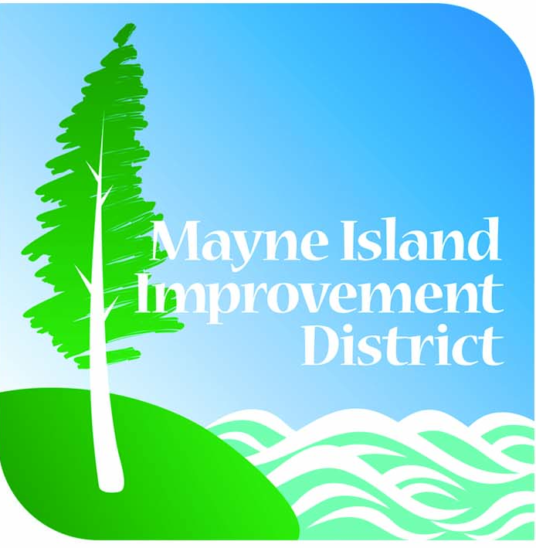

Mayne Island
Improvement
District

ANNUAL GENERAL MEETING

Saturday, July 4, 2026
at 10:00 am

Mayne Island Fire Hall
- Felix Jack Road

Presentation of Audited Financial Statements,
Trustee Elections and Annual Reports

www.miidonline.com (250) 539-5116

